**Exercise**

* **Write a program to calculate the percentage of a given student in a board exam. His marks from 5 subjects must be taken as input from the keyboard. (Marks are out of 100)**

**Approach:**

**So here we did like this**

**Marks Percentage =**

**(What is the total number you got in the exam / The sum of the all subjects highest number ) X 100**

**Solution 👇**

**Java :**

**import java.util.Scanner;**

**public class CodeXam {**

**public static void main(String[] args) {**

**System.out.println("Enter The Maximum Marks Of One Subject (example: Physics 100) ");**

**Scanner sc = new Scanner(System.in);**

**float max= sc.nextFloat();**

**max= max*5 ;**

**System.out.println("Enter the number of your Subject 1 (Physics) : ");**

**float a = sc.nextFloat();**

**System.out.println("Enter the number of your Subject 2 (Math): ");**

**float b = sc.nextFloat();**

**System.out.println("Enter the number of your Subject 3 (Biology) : ");**

**float c = sc.nextFloat();**

**System.out.println("Enter the number of your Subject 4 (Chemistry) : ");**

**float d = sc.nextFloat();**

**System.out.println("Enter the number of your Subject 5 (Optional) : ");**

**float e = sc.nextFloat();**

**float total = a+b+c+d+e;**

**System.out.println("Total marks: " + total);**

**System.out.println("Percentage of your 5 Subject is: ");**

**float Percentage = (total/max)*100;**

**System.out.println("Marks Percentage= "+ Percentage);**

**}**

**}**

**output:**

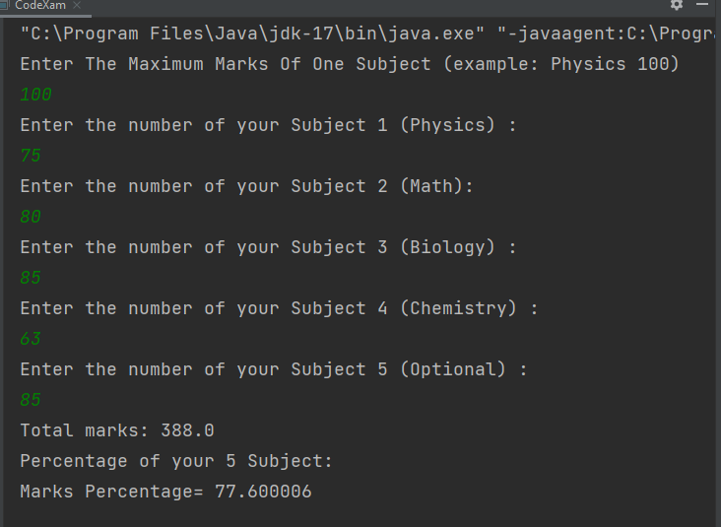

**Python :**

**maximum_numbers = int(input("Enter The Maximum Marks of One Subject (example: Physics 100) : "))**

**physics = int(input("Enter the number of your Subject 1 (Physics) : "))**

**math = int(input("Enter the number of your Subject 2 (Math) : "))**

**biology = int(input("Enter the number of your Subject 3 (Biology) : "))**

**chemistry = int(input("Enter the number of your Subject 4 (Chemistry) : "))**

**optional = int(input("Enter the number of your Subject 5 (Optional) : "))**

**total_marks = physics + math + biology + chemistry + optional**

**max_possible_marks = (maximum_numbers*5)**

**print("Total marks : ", total_marks)**

**print("Percentage of your 5 Subject is: ", (total_marks/max_possible_marks)*100)**

**output:**

